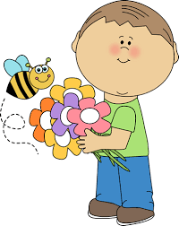
Mrs. Wilbourne’s Second Grade Class News
Week of April 30th – May 4th
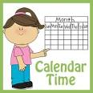  Reminders  5-03 Money for Friday’s trip is due $17.00  Parents pay at museum.  5-04 Life & Science Museum Trip and  Fun Fest  5-15 Splash Day with Coach B.  (Important information about special day is attached.)  May Birthdays  Happy Birthday to…  Megan 5-10  Nicolas 5-17  Jordyn 5-19  Notes  *Information coming home about field trip on Friday. Please remember to let me know if you are planning on going. Only adults that are allowed to attend the trip are parents/guardians/  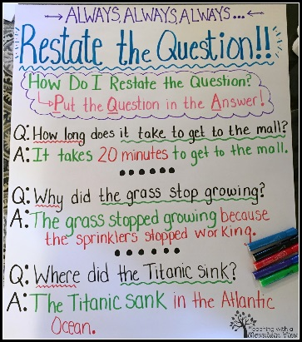  Grandparents that have been approved earlier in the school year. You can call the front office to clarify approval or tell me and I can check on it for you.  This is one strategy taught  when answering reading  written comprehension questions.  Technology Corner | Focus  Reading RL 2.2 Rl2.10 RL2.4  Analyze characters, Read from multiple perspectives  Preview text and connect to prior knowledge, Compare and contrast stories, Read with a set purpose,  I can recount folktales such as Anansi and the Pot of Beans and determine their central message or lesson.  How is this story, fable, folktale different from what you already know?  Writing RL2.9 SL2.4  Participate in a shared writing of a fairy tale  Change one or more elements to create an adaptation of a familiar fairy tale  Math 2.MD.9 2.MD.10  Generate measurement data by measuring lengths of several objects to the nearest whole unit, or by making  repeated measurements of the same object. Show the measurements by making a line plot, where the horizontal scale is marked off in whole-number units.  How can we make sense of the data we  collect?  Social Studies 2.G.1 2.G.2  Geography and Environmental Literacy  Give examples of ways in which people depend on the physical environment and natural resources to meet basic needs, Explain how people positively and negatively affect the environment.  Patricia Wilbourne  Second Grade Teacher  pwilbourne@wcpss.net  School phone: 217-5100  http://wilbournesfrogs.weebly.com
Go to Symbaloo on class website- try out
coding activity-let me know how you did!

