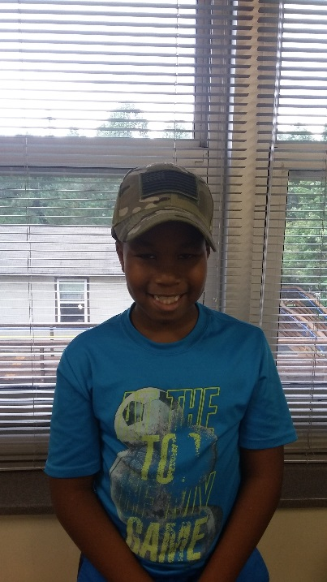

I am 7 years old. My birthday is on October 18th. I don’t have any sisters, but I have 1 brother that likes to play Nerf toys with me. My favorite subject in school is PE. When I have free time, I enjoy playing video games.

Favorite Things
Color: lime green
Food: shrimp
Animal: Jaguar
Sport: football
Movie: Galaxy of the Guardians
Song: YMCA
Book: I Survived
Game: Rocket League

Note from the Teacher
Jayden is such a joy to have in class. He SOARs each day at school. He is respectful to his teacher and peers. He follows directions and always gives it his best! We are thankful for having Jayden in class!

